**SQL Project Analysis Report**

Finding out different types of jets country have

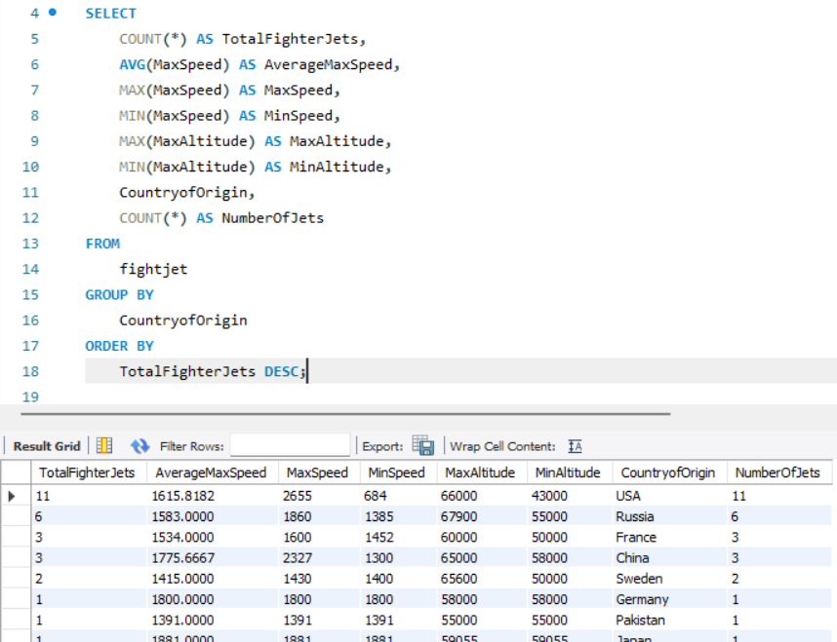

Finding out max altitude fighter jet belong to which county and name of that fighterjet.

Finding out fighter jet number as per different radar types.

Finding out which country have max fuel capacity fighter jet.

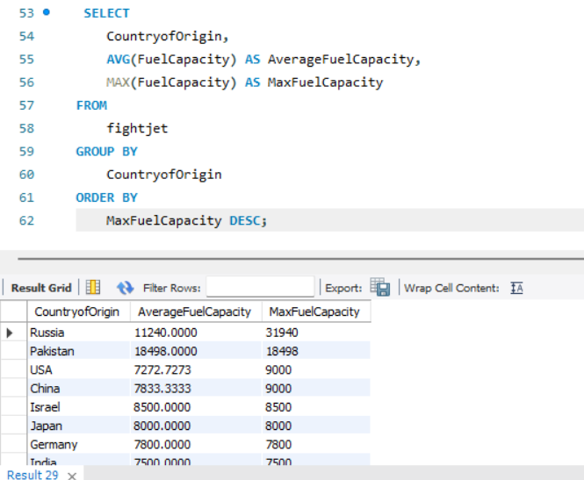

Identifying average cost per fighter jet by taking engine type in consideration.

Finding out top 10 wing span fighter jets.

Finding out how many fighter jets get introduce right from first fighter jet until now.

Most battle won fighter jet.

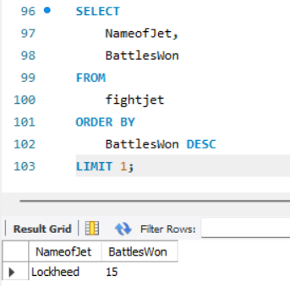

Which ejection system is used in most of the fighter jets.

Finding out which country have how many number of fighter jets according to generation of fighter jet.

Finding out fighter jet that can use all kind of weapons.

Which avionics system used in most number of fighter jets.

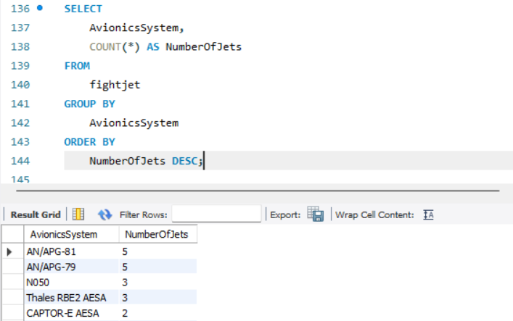

Finding out top 5 highest combat range fighter jets.

Finding out max G force top 5 fighter jets.

Finding out engine type and number of fighter jets for each country.

Finding of number of jets per country according to radar type.

Finding out which country have how many numbers of jets under different avionics system. (239)

